SENDGRID INTEGRATION WITH PYTHON CODE

|  |  |
| --- | --- |
| TEAM ID | PNT2022TMID43150 |
| PROJECT NAME | INVENTORY MANAGEMENT SYSTEM FOR RETAILERS |

# STEP 1:

REQUIREMENTS:

PYTHON 2.6,2.7,3.4 OR 3.5

# STEP 2:

CREATE AN API KEY

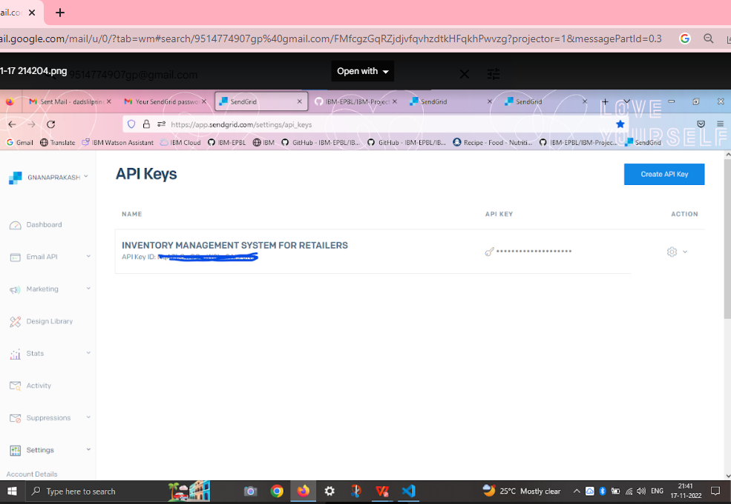

# STEP:3

INSTALL PACKAGE: > pipinstallsendgrid

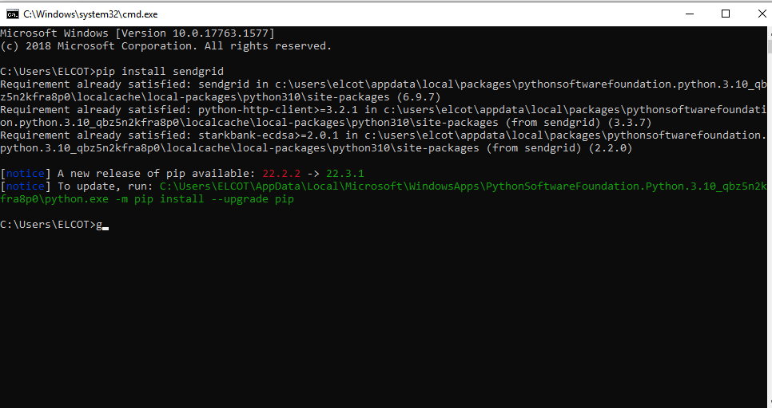

# STEP 4:

SEND EMAIL

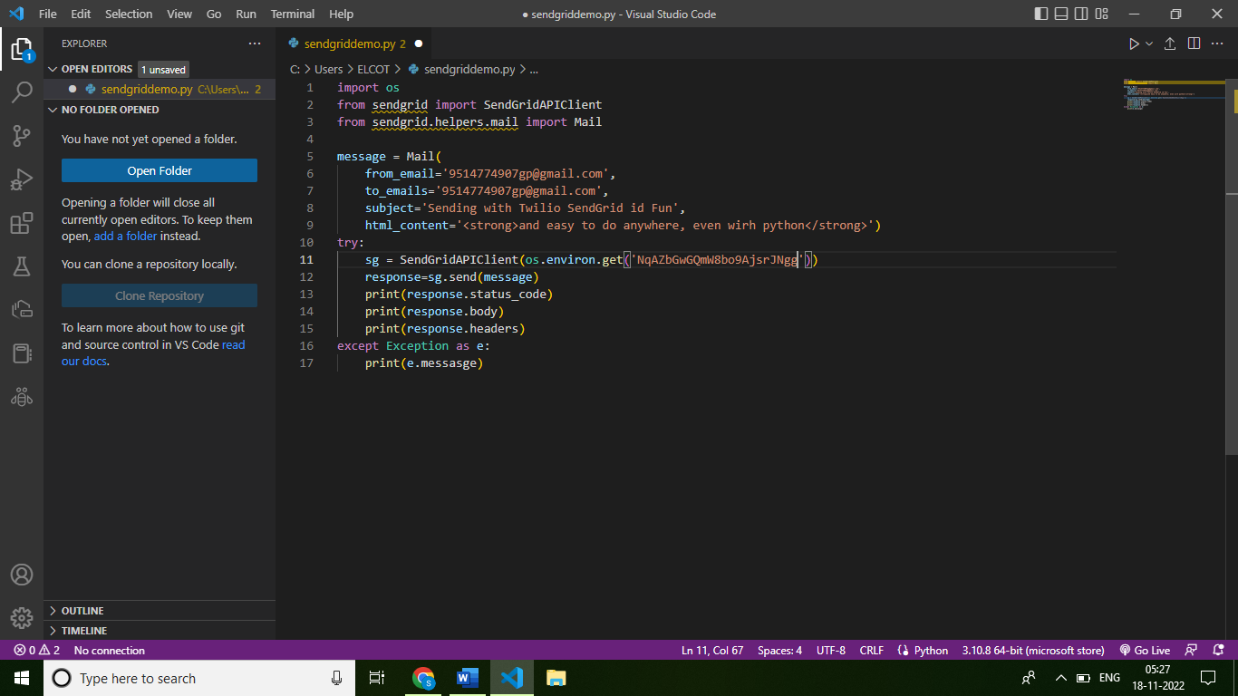

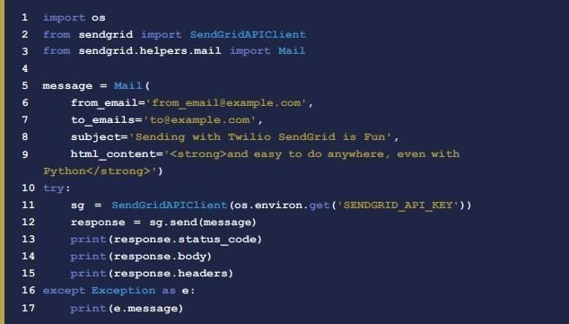**SENDGRID PYTHON CODE :**

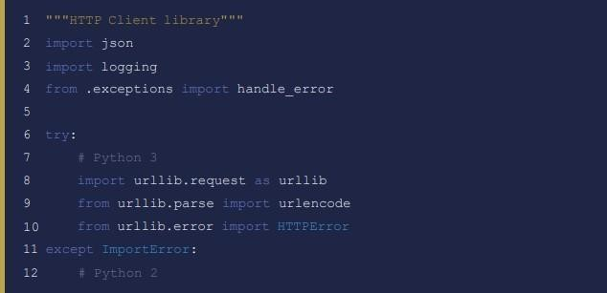**HTTP CLIENT PROGRAM**

